Sig Sigma and Offshore Outsourcing

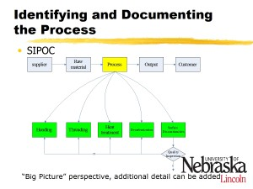
I have a special interest in Chinese manufacturing development, including Six Sigma methodology and process control. As I mention in my resume, I have worked for JianAn Auto Co. Ltd. in Chengdu, China, as well as EMG Machinery Co. Ltd. in Beijing. I combined this interest with what I learned in, University of Nebraska - Lincoln's Industrial Engineering program by focusing quality control, manufacturing, and logistical processes in Chinese manufacturing companies.

I choose to use Six Sigma in Quality control project as class project because I had a chance to work with a local firm--SpeedWay Motor Company -- which has needs relating to an out-sourcing project. As a class project, I applied my academic knowledge to real case application on process control. I run the test with a company employee to get data from final test. I then analyzed the results and presented them to SpeedWay Motor Company. Additionally, I analyze the process according data from the supplier (China) to buyer (America) by using MINITAB software package.

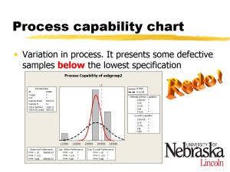
I applied the DMAIC (Design, Measure, Analyze, Improve, and Control) Six Sigma methodology to model the outsourcing. This method allowed me to seek rout cause of an international partner's defective performance from a process point-of-view. My work outlined how to increase the domestic firm's satisfaction through data monitoring for the purpose of continuous improvement through continuous tracking.

Specifically, I collected load test data from the Mechanical Test Center of the University of Nebraska - Lincoln. I used the MiniTab statistical analysis software to analyze the manufacturing process and identify defects. Other process control tools, such as SIPOC (Suppliers, Inputs, Process, Outputs, Customer) diagrams, control charts, and specifications were used in the design.

I submitted my work for my final project in Dr. Erick Jones' class, Total Quality Management I received an "A" on both the paper and the class.

The original paper, Implementing Six Sigma in Chinese Manufacturer, is available in a 687 KB Microsoft Office Word Document or as a 225 KB Adobe PDF.

