RFID Facility Layout and Supply Chain Implementation

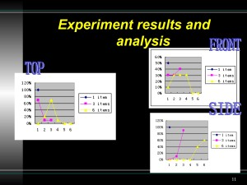
With the development of Radio Frequency Identification (RFID) techniques, the advanced research and understanding are necessary to applied techniques. I believe RFID is a powerful force in manufacture and logistic evolution and deserves more attention than ever before. The University of Nebraska - Lincoln's RfSCL (RFID & Supply Chain Logistics) Laboratory has been a fantastic environment to under and use RFID technology. As a member of Rfscl lab, I conducted a series of RFID experiments to study and help professors and fellow students on RFID related research.

For example, one experiment I conducted as part of RfSCL was to test an RFID warehouse portal door implementation system on the pallet level.

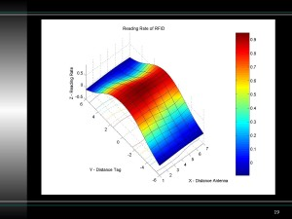
I conducted experiments on testing RFID system performance under simulated warehouse portal environments. I recorded the data for trials and ran the test using a Design of Experiment (DOE) statistical method. Meanwhile, based on the results and readability of RFID facility, I proved some effective ways to increase reading accuracy and RF facility layout options.

The experiment used four variables, antenna position, tag placement, reading range, and antenna selection, to test the performance and reliability of the RFID system. After I compiled the initial results I recommended specific RFID systems by factoring in cost of implementation as a factor.

I wrote a manuscript documenting my goal, methods, and results with Dr. Erick Jones, Dr. Chistopher Chung, and Jinxiang Pei. The paper, "Using Design of Experiments to Test RFID Portals," has been submitted for publication. I supplied the majority of the work for all aspects of the experiment.

The full document, Using Design of Experiments to Test RFID Portals, is available in a 378 KB Microsoft Office Word Document or as a 433 KB Adobe PDF file. A presentation on the same material, RFID Portal Test, is available as a 961 KB Microsoft Office Powerpoint Document or as a 2 MB Adobe PDF File.

