E-Procurement Model and Internet-based Quoting System

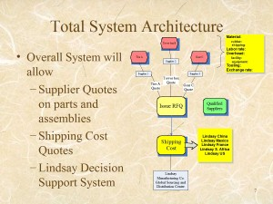
A web-based procurement system was designed for Lindsey Manufacturing, Co., a fifty-year-old manufacturing and farm & construction machinery corporation based in Omaha, Nebraska.

Lindsay Manufacturing sought to collaborate with the University to develop an e-procurement system. The company desired to reduce costs related to selection supplies, and we researched efficient methods to lower the company's transaction costs.

We focused on solutions that would reduce Lindsay Manufacturing's transactions costs while improving its ability to maintain long-term relationships with survives. After clarifying our client's operational objectives, we designed an Internet-based quoting system that fit with Lindsey's operational vision. We analyzed suppliers with both quantitative and qualitative methods to refine the quote-acceptance algorithm. The designed supported real-time Request For Quote (RFQ) process and supported a decision-building subsystem.

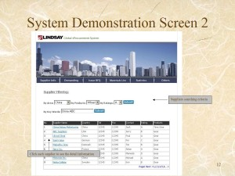
Doing this required a number of skills. We developed user-friendly interfaces to the supplier and buyer databases. Specific features were developed depending on user-role. My team combined supply chain and purchase cost analysis into the Decision Support System (DSS).

Specifically, my responsibilities included developing the system architecture for online procurement, including parts of suppliers quote, shipping cost quotes and the decision support systems. Additionally, I worked with other team members on interface developing according to the architecture of system.

We successfully informed Lindsay Manufacturing of its options, and helped a local company decide on its best strategy going forward. Additionally, Dr. Erick Jones (my thesis advisor) and I wrote an unpublished manuscript, "Strategic sourcing Procurement on Internet-based Quoting system," outlining the bidding game algorithm employed.

The original paper, Strategic Sourcing Procurement on Internet-Based Quoting System, is available in a 182 KB Microsoft Office Word Document or as a 149 KB Adobe PDF File. A presentation based on the material, Lindsay Manufacture Sourcing Project: E Business Procurement, is also available in a 844 KB Microsoft Office Powerpoint Document or as a 1.5 MB Adobe PDF File.

