The Nebraska Model

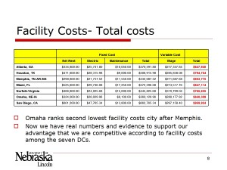
The Nebraska Model was developed for the Nebraska Department of Economic Development(NDED). I was part of a team tasked with demonstrating Nebraska as great place to start or locate a distribution-centered business.

Nebraska is located in the geographical center in United States. Logistics and supply chain costs profit directly impact the profit margin for many companies. Therefore, the objective of this project is to help the NDED to develop business opportunities for the State of Nebraska as a major Distribution Center. The target market were companies located in United States or multi-national companies with market aims in United States. We used different scenarios to prove that the State of Nebraska is a good location for Warehouse and Distribution Centers. The basic data for each scenario are transportation costs, fix costs (facility, warehouse, electricity, maintenance), and variable costs (labor). We tested different scenarios by using specific case to compare the cost of Nebraska against other states in America.
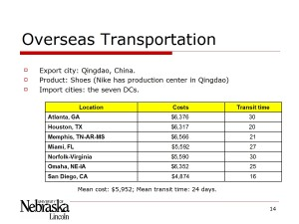
Methodologically, we factored in variables such as rents, maintenance, electricity, wages, and other relevant factors. We compared Omaha's standing to other major distribution centers, such as Atlanta, the Memphis tri-state area, as well as major ports to include special advantages cities may have due to oceanic trade. We used the "SAILS" logistic optimization software package as a mathematical toolkit.

My personal contributions included helping fellow students and co-workers to collect data for each scenario. Specifically, I was responsible for collecting data of from U.S. shipping ports to calculate the queue time and related cost.

The Nebraska Model project is still ongoing.

A presentation on the material is available in a 342 KB Microsoft Office Powerpoint Document or as a 241 KB Adobe PDF.

